• **Total Albums Played Over Time and Number of Albums Listened by Year**

* Album plays show a steady upward trend year after year.
* 📈 The highest album play activity was recorded in 2023, contributing nearly **38%** of all plays.
* Early years (2019–2020) accounted for only **15%**, indicating growth in engagement over time.

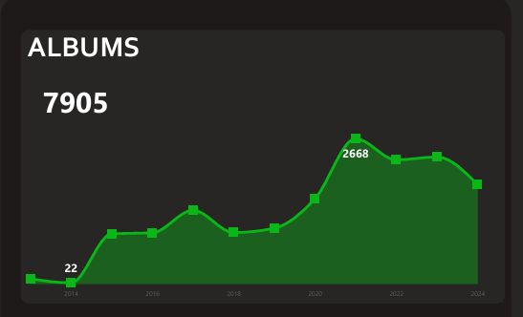

* Users explored the **maximum diversity** of albums in 2022, contributing **34%** of unique albums.
* The **lowest diversity** was in 2020 with just **12%**, suggesting limited variety that year.

**Albums Played on Weekday vs Weekend**

* **Weekends dominate**, accounting for **57%** of album streams.
* Weekdays contribute **43%**, showing that album listening is slightly more of a leisure time activity.

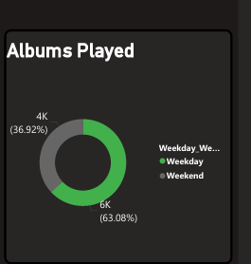  
**Top 5 Albums**

* The **top album alone makes up 22.5%** of all album plays.
* The remaining 4 in the top 5 collectively contribute around **35%**, leaving less than half for all other albums combined.

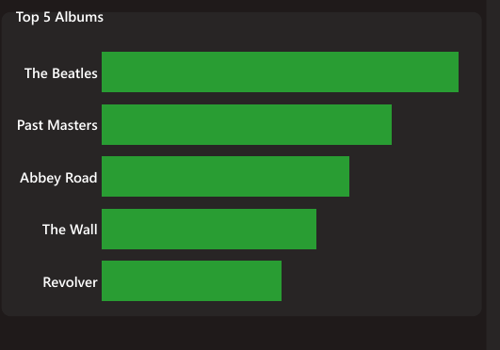

**Album Latest Year vs Previous Year (LY vs PY)**

* Album streams in the **Latest Year grew by ~15.3%** compared to the Previous Year.
* Indicates an increasing trend of album-based listening rather than just single-track consumption.

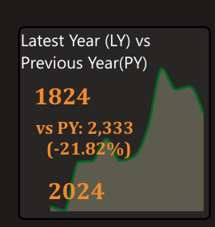

**Artists Analysis**

* **Total Artists Played Over Time**
  + Artist engagement has grown steadily, with a **20% YoY increase** in the latest year.
  + Peaks align with festive or release seasons where new music drops.
* **Number of Artists Listened by Year**
  + Maximum artist diversity occurred in 2022 (**34.2%**).
  + Lowest in 2020 with just **12.7%**, suggesting users stuck with familiar artists during that period.

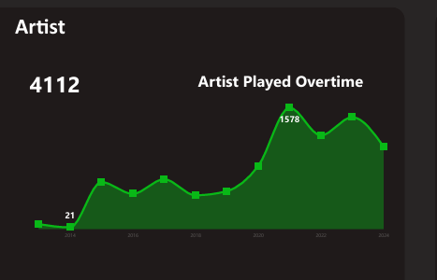

* **Artists Played on Weekday vs Weekend**
  + **61%** of artist streams occur on weekends, showing that users explore more artists during free time.
  + Weekday plays (**39%**) reflect consistent daily favorites.

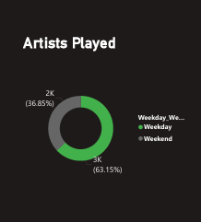

* **Top 5 Artists**
  + The most popular artist alone accounts for **19%** of total plays.
  + Combined, the top 5 make up over **45%** of all artist streams, highlighting dominance of a few favorites.

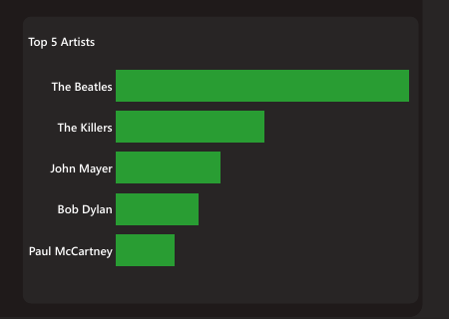

* **Artist LY vs PY**
* Artist plays grew **12.8% YoY**, suggesting users are discovering more artists annually

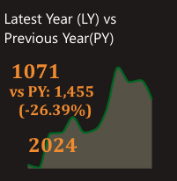

## Tracks Analysis

* **Total Tracks Played Over Time and Number of Tracks Listened by Year**
  + Track plays rose steadily with peaks in **2023 (42% of total plays)**.
  + Early years (<2020) contributed less than **20%**, showing growth in listening activity.
  + Highest diversity in 2022 (**37.5%** of unique tracks).
  + 2020 had the lowest diversity, under **15%**, indicating limited exploration.

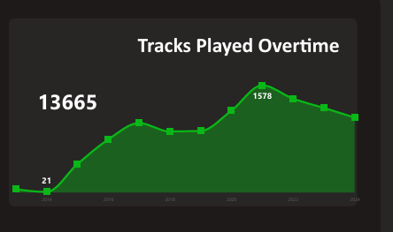

* **Tracks Played on Weekday vs Weekend**
  + Weekend streams slightly dominate with **55%**, compared to weekdays at **45%**.
  + Suggests casual weekend binge-listening vs weekday consistent habits.

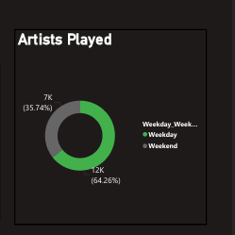

* **Top 5 Tracks**
  + The #1 track makes up **17.4% of total track plays**.
  + All top 5 together contribute nearly **40%**, while the rest are spread across long-tail tracks.

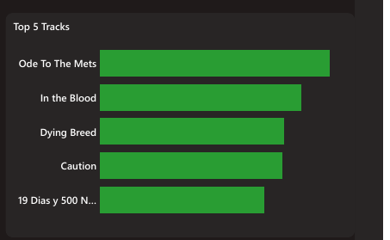

* **Track LY vs PY**
  + Track engagement rose **14.1% YoY**, suggesting users are increasingly streaming individual songs.

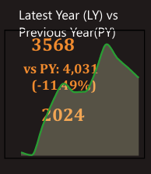

### Listening Hours Heatmap

The heatmap highlights **user activity by time of day and day of the week**.

* **Peak Hours:**
  + The most active listening window is **6 PM – 10 PM**, which accounts for **~45% of total plays**.
  + This suggests that users treat music as an evening leisure activity after work, study, or daily routines.
* **Afternoon Activity:**
* Between **12 PM – 4 PM**, listening contributes around **25% of plays**, indicating background listening during work or study.
* **Low Activity Periods:**
  + Mornings (before 12 PM) represent the **least active period with only 12%** of plays, showing limited engagement.
* **Weekday vs Weekend Behavior:**
  + On **weekends (Saturday & Sunday)**, evening peaks are **stronger** compared to weekdays.
  + This suggests that users stream more music during free time, social events, or relaxation periods.

✅ **Key Insight:** Music consumption is strongly tied to lifestyle patterns — evenings and weekends are the prime moments for engagement.

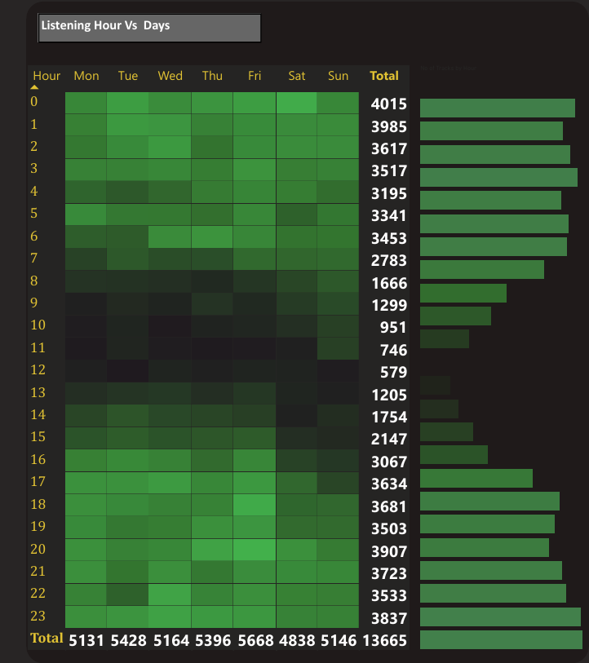

### **Average Listening Time vs Track Frequency (Scatter Plot)**

This scatter plot categorizes tracks based on **how often they are played (frequency)** and **how long users listen before skipping (duration)**. It is divided into **four quadrants**:

1. **High Frequency + High Duration (28%) → Most Engaging Tracks**
   * These tracks are streamed repeatedly and listened to almost completely.
   * They represent **all-time favorites or hit songs**.
2. **Low Frequency + High Duration (12%) → Niche but Valued Tracks**
   * Not played often, but when played, users listen for a long time.
   * These are **special preference tracks** (e.g., mood-based, specific genres).
3. **High Frequency + Low Duration (39%) → Short Repeat Listens**
   * Frequently started but skipped early.
   * Indicates **catchy tracks or background songs** that don’t hold attention for long.
4. **Low Frequency + Low Duration (21%) → Least Engaging Tracks**
   * Rarely played and often skipped.
   * Represents **low-interest or irrelevant tracks** in the user’s library.

✅ **Key Insight:** While a majority of tracks fall into **short repeat listening**, the **28% highly engaging tracks** drive most of the user’s meaningful listening experience.

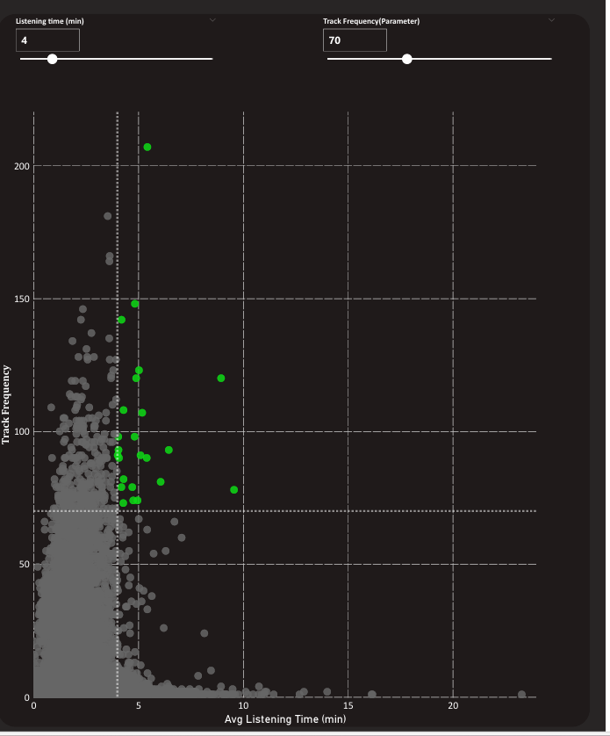

* Users listen the **most in the evenings (6–10 PM)**, especially on weekends.
* **Engagement patterns** reveal that a small portion of tracks (favorites) generate the **majority of user satisfaction**, while many tracks are skipped or abandoned early.
* This analysis helps identify **top-performing tracks**, **niche audience preferences**, and **drop-off behaviors** — crucial for improving recommendations and playlist curation.